Project Report

Internship Project Report

On

**Intelligent Customer Help Desk with Smart Document Understanding**

A Summer Internship Report Submitted to

Hemwati Nandan Bahuguna Garhwal University

In Partial Fulfilment

For the Award of the Degree of

Bachelor of Technology

In

Computer Science & Engineering

By

Kartikeya

Under

Smartinternz

**PROJECT SCOPE**

* ***Poject summary:***

The program chatbot offers a complete and easy way to answer different sets of questions asked by the customers. With the help of Watson discovery channel it can also answer some typical questions about the operation of a device becaus we have feede the owners manual to the watson discovery channel. The beneﬁts of this kind of chatbot is that it is superior than the typical chatbot which can answers simpe questions like store location and hours. The chatbot is upgraded with the help of watson discovery collection which is build using smart document understanding.

It's main objective is to solve customer's queries as early as possible to save the time of the customer. We will use the IBM cloud function that allows watson assistant to post queries to watson discovery.

The goal is to set up a remote connection between the customer and the company. By this chatbot anyone can have their problem solved by posting queries to chatbot via being at home or without calling an employee.

* ***Project Requirements:***

The project Requirements are:-

1. IBM Cloud
2. IBM Watson services
3. Node Red
4. Web Framework

* ***Functional Requirements*:**

The functional requirements of this project are:

1. A Chatbot able to answer queries.
2. Redirect the operational queries to Owner's manual.
3. Redirect the query to the particular section of the owner's manual.

* ***Technical Requirements:***

The technical requirements for this project are:

1. Create a chatbot using Watson Assistant.
2. Use Watson Discovery to redirect the user's query to the section of the owner's manual.
3. Use Node Red to wire together Api and online services.
4. Integrating it with IBM Cloud.

* ***Software Requirements:***

The software which are required to build the chatbot are:

1. IBM Watson services
2. IBM Assistant
3. IBM cloud
4. Github
5. Node red
6. User interface
7. Security
8. Json editor

* ***Project Deliverables:***

The model created i.e. a chatbot would be able to identify any operational question posted by the user and using IBM Watson discovery will redirect the user to the section of the owner's manual where the answer to the question lies.

* ***Project Team***

I'm working individually on this project i.e to make a chatbot using Watson Discovery and SDU.

Table of contents

Declaration Acknowledgement

###### INTRODUCTION

* + 1. Overview
    2. Purpose

###### LITERATURE SURVEY

* + 1. Exisfing problem
    2. Proposed solufion

###### THEORITICAL ANALYSIS

* + 1. Architecture
    2. Sohware designing

###### FLOWCHART

* 1. **RESULT**
     1. Advantages
     2. Disadvantages

###### APPLICATIONS

* 1. **CONCLUSION**
     1. Future Scope **REFERENCES APPENDIX**

**Chapter-1**

**Introduction**

In this project a chatbot is created which offers a complete and easy way to answer different sets of questions asked by the customers. With the help of Watson discovery channel it can also answer some typical questions about the operation of a device

because we have feeds the owners manual to the watson discovery channel. The

beneﬁts of this kind of chatbot is that it is superior than the typical chatbot which can answers simple questions like store location and hours. The chatbot is upgraded with the help of watson discovery collection which is build using smart document understanding.

It's main objective is

* To solve student's queries as early as possible to save the time of the customer.
* We will use the IBM cloud function that allows Watson assistant to post queries to Watson discovery.
* The goal is to set up a remote connection between the customer and the company.

By this chatbot any students can have solved their problem by posting queries to chatbot via being at home.

* 1. **Overview**

The typical customer care chatbot can answer simple questions, such as store locations and hours, directions, and maybe even making appointments. When a question falls outside of the scope of the pre-determined question set, the option is typically to tell the customer the question isn’t valid or offer to speak to a real person.

In this project, a chatbot is created which offers a complete and easy way to answer different sets of questions asked by the students. With the help of Watson discovery channel it can also answer some typical questions about the operation of a device because we have feeds the owners manual to the Watson discovery channel.

To take it a step further, the project shall use the Smart Document Understanding feature of Watson Discovery to train it on what text in the owners manual is important and what is not. This will improve the answers returned from the queries.

## **Purpose**

* + - To solve student's queries as early as possible to save the time of the customer.
    - We will use the IBM cloud function that allows watson assistant to post queries to Watson discovery.
    - The goal is to set up a remote connection between the student and the e-learning websites.

Chapter 2

LITERATURE SURVEY

The literature review method is an examination of information on speciﬁc subject. It is reviewing what is known and not what is assumed. It aims to create the ﬁnal, precise representation of the knowledge and research-based theory available topic

## **Exisfing Problems**

The typical customer care chatbot can answer simple questions, such as store

locations and hours, directions, and maybe even making appointments. When a question falls outside of the scope of the pre-determined question set, the option is typically to tell the customer the question isn’t valid or offer to speak to a real person.

## Proposed solufion

So, the solution is that, If the customer question is about the operation of a device, the application shall pass the question onto Watson Discovery Service, which has been pre-loaded with the device’s owners manual. So now, instead of “Would you like to speak to a customer representative?” we can return relevant sections of the owners manual to help solve our customers’ problems.

Chapter-3

THEORITICAL ANALYSIS

Conversations play an important role in everyday life. Conversation can be general

which are used to generate fun or they can be used to solve queries. For any

conversation in general at least two people are required. Conversation can also occur between a computer and a human. Such conversations can be achieved through chatbots.

###### **What is a Chatbot?**

Chatbot is made up of two words “Chat” representing conversation and “Bot” representing a robot. Hence a chatbot is enabling conversations with a robot.

* + - Generally speaking a bot is any software that performs an automated task, however, we are interested in the class of bots that live online in chat platforms or on social media called chatbots.
    - In this context, there are many possible deﬁnitions and some confusion about what a bot is. This is partly because there are so many varied use cases for bots and these inﬂuence what people perceive a chatbot to be.
    - The most intuitive deﬁnition is that a bot is software that can have a

conversation with a human. For example, a user could ask the bot a question or give it an instruction and the bot could respond or perform an action as appropriate.

###### **Types of Chatbots**

To understand the nature of chatbot conversations it is important to understand that there are three types of chatbots:

* + - ***Scripted Chat Bot*** :

These are chatbots whose behaviour is determined by rules. Conversations with this type of chatbot can only follow predetermined paths. At each step in the conversation the user will need to pick from explicit options to determine the next step in the conversation. How the options are presented to

the user at each step in the conversation, i.e. whether they need a text, voice or

touch response will depend on the features of the chat platform and how the bot is programmed that the user is on and the design of the bot.

* + - ***Intelligent Chat Bot*** :

Intelligent chatbots are built with artiﬁcial intelligence

techniques. Artiﬁcial intelligence allows them to be more ﬂexible in terms of the user input they can accept. They can accept free form input in the form of text or voice statements (but of course they are not limited to other forms of input if that makes sense). AI also allows them to improve the more that they are used. It should be noted however that although AI works very well in very limited knowledge domains, or for one off instructions, the actual intelligence of the bot is limited. It is extremely diﬃcult to get a bot to “understand” context or ambiguity or to have a useful memory that inﬂuences the conversation.

* + - ***Application Chat Bot*** :

Both scripted and intelligent chatbots can have graphical user interfaces. As mentioned, both scripted and intelligent chatbots can have graphical user interfaces. Application bots is therefore not a separate category of bots per say. The fact that the bots can be interacted with using a graphical user interface is an important concept for chatbot developers. If a user can do the job they need to do more eﬃciently via a graphical interface then the bot needs to show a graphical interface at that point in the conversation.

###### **Why chatbots are important?**

Chatbot applications streamline interactions between people and services, enhancing customer experience. At the same time, they offer companies new opportunities to improve the customer engagement process and operational eﬃciency by reducing the typical cost of customer service.

To be successful, a chatbot solution should be able to effectively perform both of these tasks. Human support plays a key role here: Regardless of the kind of approach and the

platform, human intervention is crucial in conﬁguring, training and optimizing the chatbot system.

###### How a chatbot works ?

A chatbot performs two main tasks

1. User request analysis
2. Returning response

The ability to identify the user’s intent and extract data and relevant entities contained in the user’s request is the ﬁrst condition and the most relevant step at the core of a chatbot: If you are not able to correctly understand the user’s request, you won’t be able to provide the correct answer. Returning the response: once the user’s intent has been identiﬁed, the chatbot must provide the most appropriate response for the user’s request. The answer may be:

* A generic and predeﬁned text
* A text retrieved from a knowledge base that contains different answers
* A contextualized piece of information based on data the user has provided
* Data stored in enterprise systems
* The result of an action that the chatbot performed by interacting with one or more backend application
* A disambiguating question that helps the chatbot to correctly understand the user’s request
  1. **ARCHITECTURE OF A CHATBOT**

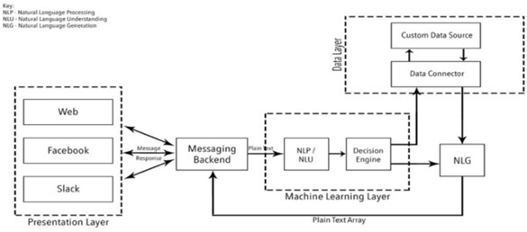

* 1. **SOFTWARE DESIGNING**

The software which are required to build the chatbot are:

* + 1. IBM Watson services
    2. IBM Assistant
    3. IBM cloud
    4. Github
    5. Node red
    6. User interface
    7. JSON Editor

##### ***#* Creafing a Chatbot on IBM Cloud**

Process for creating a Restaurant Chatbot using IBM cloud is shown below. To build a chatbot 3 important things are to be built, they are

* Intents : An intent is a collection of user statements that have the same meaning. By creating intents, you train your assistant to understand the variety of ways users express a goal. (represented using #)
* Entities : Entities are like nouns or keywords. By building out your business terms in entities your assistant can provide targeted responses to queries. (represented using @)
* Dialog : Bot responses to the user queries are mentioned in Dialogue. Dialog contains two pre deﬁned nodes. One is Welcome node and the other is Anything else node. The Welcome contains the text to be displayed to start the

conversation. Anything else node triggers when no node conditions are satisﬁed. All the other node lie between these two nodes only.

Apart from these three, context variables are used to store user mentioned content which bot have to remember for future conversation like the person’s name, email-id or any other details.

In the given example 2 context variables are used one for storing the item name for which the order has to be placed and other for storing the number i.e., the quantity of the food_item for which the order has to be placed. These contexts are stored in the

bots memory and once the processing of the information is done these contexts can be deleted using simple JSON code.

At the end of the process the bot is integrated to a sample page provided by IBM. Apart from the page, the bot can also be integrated to Third Party Integrations like Slack, Facebook page, Intercom or Standalone Integrations like Web Chats or Preview link or as a Wordpress plugin.

*S TEPS:*

1. Create an IBM account by logging in into [h ttps://cloud.ibm.com/](https://cloud.ibm.com/) and clicking on Create an IBM account.
2. Fill the details and create an IBM account
3. Verify your email id and then login into IBM account by clicking on Login.
4. After the login dashboard is launched. On dashboard all the created resources will be displayed.
5. To create a chatbot on IBM cloud we require Watson Assistant service. All the available resources on the cloud are found under the catalog section. Open

Catalog. Under categories select AI and in that Watson Assistant service is found.

1. Click open the Watson Assistant service. Select the region, pricing plan and give a name to the service and click on Create. It’s showing me a warning because I have already created this.
2. On launch page click on Launch Watson Assistant.

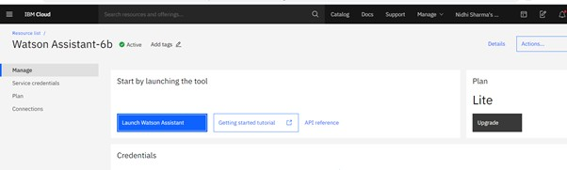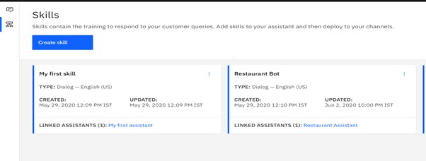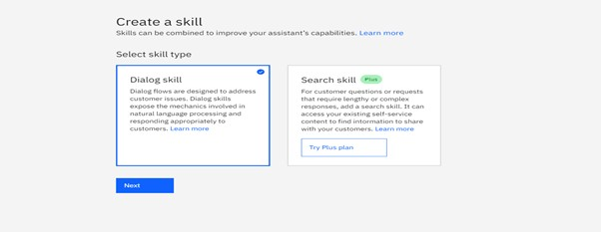

1. Assistant page is launched. On the left pane click on skills.
2. On the launch page click on Create Skill. Select the skill type to be Dialog Skill and click on Next.
3. Skill can be created in 3 different ways. Select Create Skill tab and give a name to your skill (also optionally description) of the skill and click on Create a Dialog

Skill.

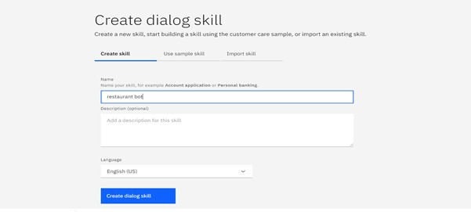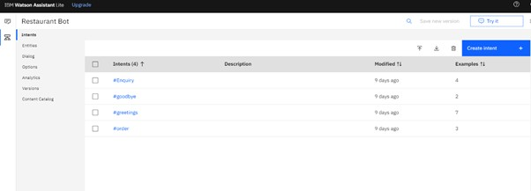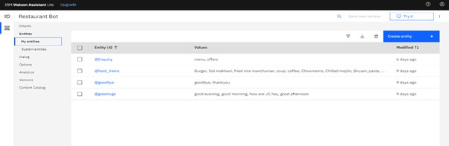

1. You can create Intents, Entities and Dialog. and Click on Try it on the right side of the screen and check try giving the greetings and check the response.

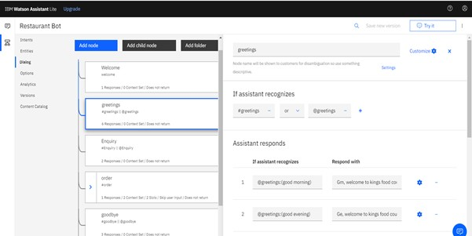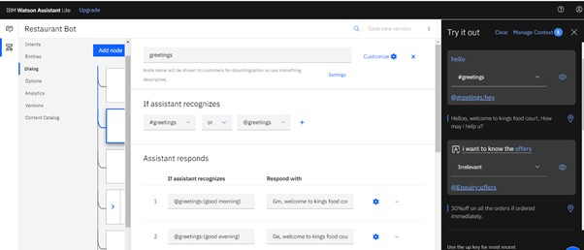

1. From the left pane click on Assistants. Click on Create Assistant. Give a name to the assistant and click on Create Assistant. On the launch page under Dialog click. Add dialog skill. Under Add existing skill click on the previously created skill. Under my case it's Restaurant Bot.

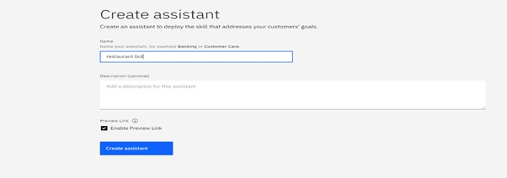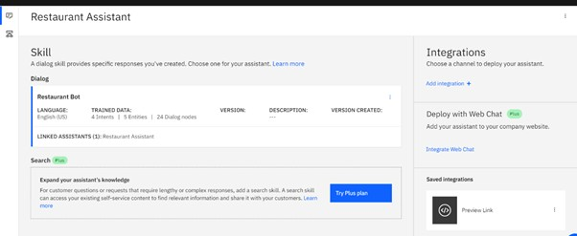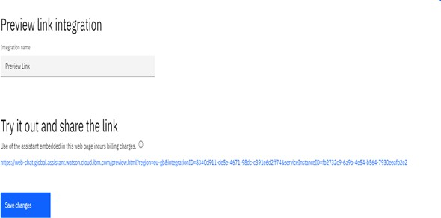

1. Under saved integrations click Preview Link. Click on the link on the launch page, give a name to the integration and save the changes.
2. Test the bot with the preview given by IBM.

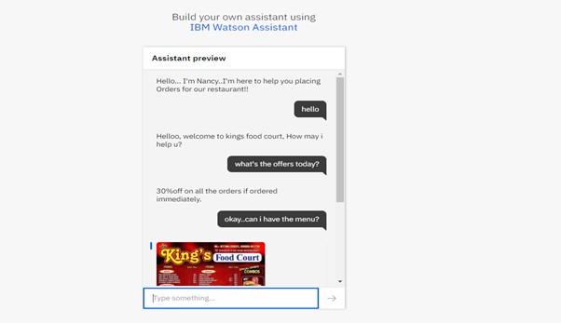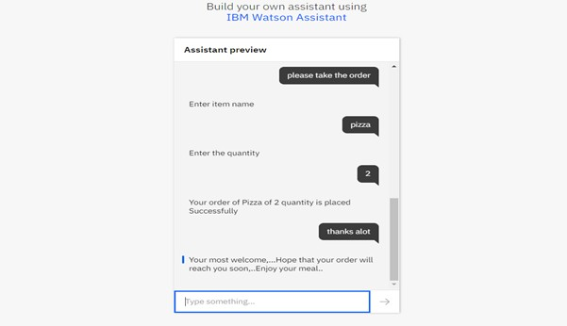

You can integrate the bot with any other third party services or html pages.

##### *# Creafing UI of Watson Assistant with Node red ﬂow (Chatbot).*

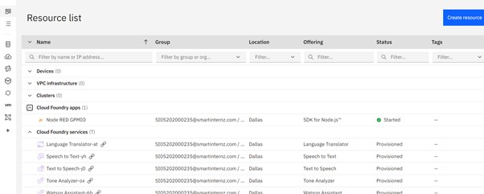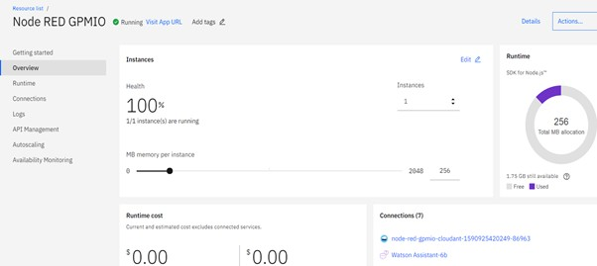

**1.** Click on the services in the dashboard. Go to the Cloud Foundary apps.And click on Node red app.(Here I,m assuming that you have already created the Node-red services).

**2.** A node red dashboard appears as shown below:

1. Click on Visit app URL. A page appears. Click on Go to your node red ﬂow Editor.

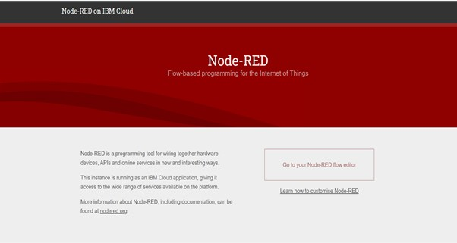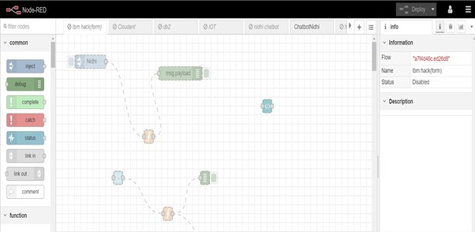

1. Node-Red-ﬂow-Editor page appears as shown below:
2. Click on import. Copy the json ﬂow from the local repo and paste it here. and click import to new ﬂow. The ﬂow got created.

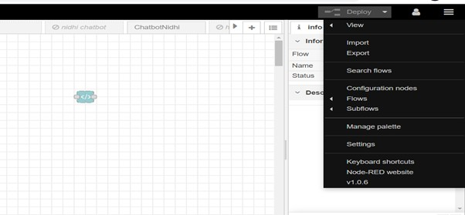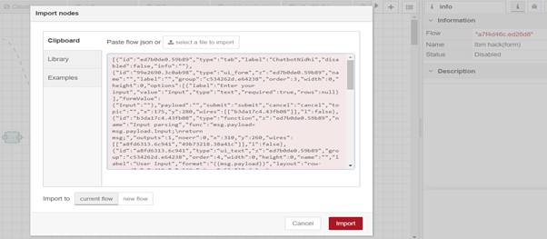

1. Here's the ﬂow:

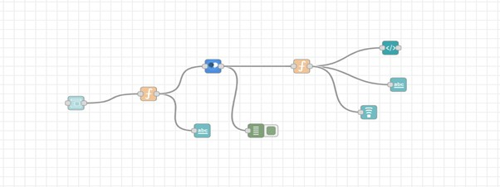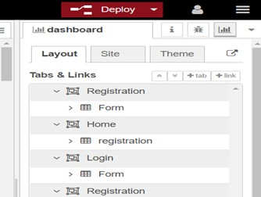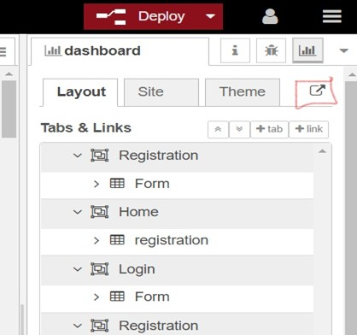

1. Deploy your Flow. Click on the dashboard. Also add the workspace Id and Service endpoint.
2. UI is created successfully. Click on that arrow button present near the themes.
3. The output is shown as below:

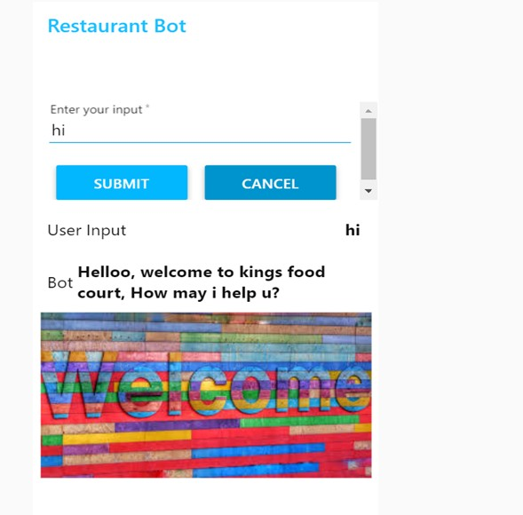

Chapter-4 FLOWCHART

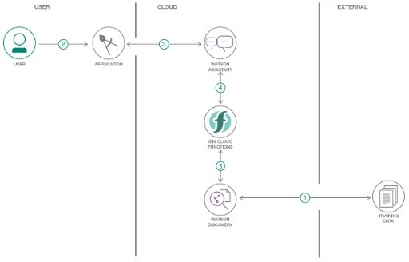

1. The document is annotated using Watson Discovery Smart Document Understanding.
2. The user interacts with the back-end server via the app UI. The front-end app UI is a chatbot that engages the user in a conversation.
3. Dialog between the user and back-end server is coordinated using a Watson Assistant dialog skill.
4. If the user asks a product operation question, a search query is passed to a predefined IBM Cloud Functions action.
5. The IBM Cloud Functions action will query the Watson Discovery Service and return the results.

Chapter-5 RESULTS

* We have Created a Chatbot which is able to answer queries.
* The model created i.e. a chatbot would be able to identify any operational

question posted by the user and using IBM Watson discovery will redirect the user to the section of the owner's manual where the answer to the question lies.

## ADVANTAGES

Chatbots have been on the rise since a couple of years and have already faced a wide adoption. They are bringing a new way for businesses to communicate with the world and most importantly with their customers by the help of exploding popularity of messaging apps, the accelerated development of all kinds of sensors and wearables and of course with the rise of emerging technologies and Artiﬁcial

Intelligence (AI).

###### Keeping Up with the Trends: Being Present on Messaging Platforms

* + - **Improved Customer Service.**
    - **Always-Available Customer Support**
    - **Proactive Customer Interaction**
    - **Increased Customer Engagement**
  1. DISADVANTAGES

This definition however often leads to two potential misconceptions.

1. The biggest misconception that arises is that a chatbot is a bot that converses with a human in the way that another human would converse with a human. Software or even a robot (the digital part of the robot is of course software) that communicates with a human in natural language is not difficult to imagine. Science fiction is full of examples. While this may be the end goal, this is simply not possible using the current technology.
2. The second misconception is that a chatbot communicates using only text or voice. Actually chatbots allow users to interact with them via graphical interfaces or graphical widgets, and the trend is in this direction. Many chat platforms including WeChat, Facebook Messenger and Kik allow web views on which developers can create a completely customized graphical interfaces.

Chapter-6 APPLICATIONS

A Chatbot is a program that can have a conversation with a person using rules and

Artiﬁcial Intelligence (AI) in a way that mimics human-like conversations and interactions. Chatbots have become popular in the past few years as businesses discover innovative ways to put them to use. Having a Chatbot today has n [umerous](https://www.cxservice360.com/2017/10/18/5-ways-your-business-will-benefit-from-chatbots/)

b [eneﬁts for businesses](https://www.cxservice360.com/2017/10/18/5-ways-your-business-will-benefit-from-chatbots/) – they make life easier for customers, are available 24/7, save time (no more long waits to talk to a service rep) and they are easy to use.

* + - ***C***

***ontent delivery:***Media Publishers have realized that chatbots are a

powerful way to engage with their audiences and monitor engagement to gain valuable insights on reader interests.

* + - ***O rder Food:*** Various fast food giants like KFC and Pizza Hut have invested in

Chatbots that enable customers to place their orders through conversations. Taco Bell went a step further to improve the conversational experience by giving their Chatbot named TacoBot some personality.

* + - ***B ook Flights:*** Icelandair’s chatbot gives their customers the ability to search

for and book ﬂights in a text-based conversational manner. Instead of drop-down menus, customers enter the information themselves.

* + - ***C ompanionship:*** Russian technology company Endurance developed its

c [ompanion chatbot](http://endurancerobots.com/azbnmaterial/a-robot-companion-for-senior-people-and-patients-with-alzheimer-s-disease/) for Senior People and Patients with Alzheimer’s Disease. The primary function of the chatbot is to be a virtual companion – To speak with senior people on general topics like the weather, nature, hobbies, movies, music, news, etc. The chatbot asks questions, reacts to the answers, is able to speak on various topics, and share interesting news and facts from Google

* + - *H ealth Care:*Chatbots have also made their way into health care by easing the

burden on medical professionals by facilitating faster medical diagnosis, answering health-related questions, booking appointments and lots more. A Chatbot like S [uper Izzy](https://www.messenger.com/t/1132368360164136) can track menstrual cycles, dates and fertile windows.

Chapter-7 CONCLUSION

There is more to building chatbots and conversational UI than just plugging tools,

services, and data together. It takes practice and a deeper understanding of underlying concepts to get the design right and build bots that give users a great experience. The user should be able to get the job done by having a conversation with the bot without having to think too much and with a smile on their face.

From my perspective, chatbots or smart assistants with artiﬁcial intelligence are dramatically changing businesses. There is a wide range of chatbot building platforms that are available for various enterprises, such as e-commerce, retail, banking, leisure, travel, healthcare, and so on.

Chatbots can reach out to a large audience on messaging apps and be more effective than humans. They may develop into a capable information-gathering tool in the near future.

# FUTURE SCOPE

Chatbots are hot software in the enterprise, but to maintain longevity and relevance, developers need to take a look at the barriers to entry, interface options and NLP issues.

From gauging purchase intent to answering questions about IT issues, chatbots are on track to play a major role in the contemporary enterprise. Chatbots are fully functioning, semi-autonomous systems that can assist customer service experiences and response time.

The clearest use of chatbots right now is in customer service and online ordering, where it can automate (and in some cases solve) customer issues or complete orders without human interaction.

* + - Adding Natural Language Processing in the Bot to understand the User Statements.
    - Adding Sentiment Analysis to predict User Sentiment during the Chat.
    - Use Voice Capabilities of the Bot.
    - Use Voice Recognition with Bot.

REFERENCES

[1].[h5ps://www.cxservice360.com/2018/06/27/10-interesfing-applicafions-of-chatbots-2/](https://www.cxservice360.com/2018/06/27/10-interesting-applications-of-chatbots-2/) [2]. [h5ps://github.com/IBM/watson-discovery-sdu-with-assistant](https://github.com/IBM/watson-discovery-sdu-with-assistant)

[3].

[h5ps://github.com/Nidhi786sharma/Intelligent-Customer-Help-Desk-with-Smart-Document-Understandi](https://github.com/Nidhi786sharma/Intelligent-Customer-Help-Desk-with-Smart-Document-Understanding) [ng](https://github.com/Nidhi786sharma/Intelligent-Customer-Help-Desk-with-Smart-Document-Understanding)

[4].

[h5ps://developer.ibm.com/pa5erns/enhance-customer-help-desk-with-smart-document-understanding/](https://developer.ibm.com/patterns/enhance-customer-help-desk-with-smart-document-understanding/)

[5].

[h5ps://dzone.com/arficles/signiﬁcance-of-chatbot#:~:text=Conclusion,intelligence%20are%20dramafical](https://dzone.com/articles/significance-of-chatbot#%3A%7E%3Atext%3DConclusion%2Cintelligence%20are%20dramatically%20changing%20businesses.%26text%3DChatbots%20can%20reach%20out%20to%2Ctool%20in%20the%20near%20future) [ly%20changing%20businesses.&text=Chatbots%20can%20reach%20out%20to,tool%20in%20the%20nea](https://dzone.com/articles/significance-of-chatbot#%3A%7E%3Atext%3DConclusion%2Cintelligence%20are%20dramatically%20changing%20businesses.%26text%3DChatbots%20can%20reach%20out%20to%2Ctool%20in%20the%20near%20future) [r%20future.](https://dzone.com/articles/significance-of-chatbot#%3A%7E%3Atext%3DConclusion%2Cintelligence%20are%20dramatically%20changing%20businesses.%26text%3DChatbots%20can%20reach%20out%20to%2Ctool%20in%20the%20near%20future)

[6].

[h5ps://www.uio.no/studier/emner/matnat/iﬁ/IN5480/h18/deliverables/group-assignment/ﬁnal-reports](https://www.uio.no/studier/emner/matnat/ifi/IN5480/h18/deliverables/group-assignment/final-reports/finalreport-vildehos_annassc_martrim.pdf)

[/ﬁnalreport-vildehos_annassc_martrim.pdf](https://www.uio.no/studier/emner/matnat/ifi/IN5480/h18/deliverables/group-assignment/final-reports/finalreport-vildehos_annassc_martrim.pdf) [7]. Watson Assistant with Webhooks:-

[h5ps://www.youtube.com/embed/5z3i5IsBVnk](https://www.youtube.com/embed/5z3i5IsBVnk)

[8]. Cloud Funcfions Acfion:-

[h5ps://www.youtube.com/embed/G3bqRndQtQg](https://www.youtube.com/embed/G3bqRndQtQg)

# APPENDIX

###### For source code visit:-

[h5ps://github.com/SmartPracficeschool/llSPS-INT-1858-Intelligent-Customer-Help-Desk-with-Smart-Doc](https://github.com/SmartPracticeschool/llSPS-INT-1858-Intelligent-Customer-Help-Desk-with-Smart-Document-Understanding) [ument-Understanding](https://github.com/SmartPracticeschool/llSPS-INT-1858-Intelligent-Customer-Help-Desk-with-Smart-Document-Understanding)